**AMBER**

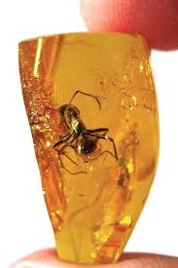 **Name:** Succinite Amber

**Brand:**  Riedel

**Model#:** 006

**Color:** Honey

**Price: $200 million**